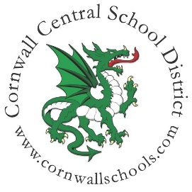
CORNWALL CENTRAL SCHOOL DISTRICT
AUDIT COMMITTEE MEETING
MINUTES
Date & Time: Wednesday, October 8, 2025, 6:00pm
Location: Cornwall District Office – Basement Conference Room

Mission:
The Cornwall Central School District is committed to working together with the community to provide a secure and nurturing environment of diverse learning opportunities for all students.

It is our goal to help students achieve their dreams and aspirations and to prepare them to confidently face challenges while promoting the strength of mind, body, and character.

Vision:
We envision a school district in which every staff member is a source of knowledge and inspiration, every building is a place of safety and support, every leader is a pillar of integrity, and every student is a source of pride.

Purpose:
The Audit Committee will meet to review all audits and practices related to the fiscal operations of the District in accordance with Board policies and present their findings and any recommendations to the entire Board of Education.

Committee Members Present: Christian Brunelli - Chairperson, Christine Diaz, Carl Gilpatrick
Administrative Team Present: Megan Argenio, John Fink
Guests Present: Nugent & Haeussler, PC: Mark Levine

Agenda Items:

- 2024-2025 Internal Audit Report by Nugent & Haeussler, PC – Mark Levine discussed the 2024-2025 risk assessment report and the internal audit report which focused on purchasing, accounts payable and cash disbursements. The committee engaged in questions, answers and dialogue regarding the findings from the report. The committee approved both the risk assessment report and the internal audit report.
- Corrective Action Plan for Internal Audit Report – John Fink prepared and shared the corrective action plan with the committee and Mark Levine. The committee discussed and approved the plan.
- Internal Audit Plan for 2025-2026 School Year – The committee discussed the internal audit plan for the 2025-2026 school year. The audit will take place in the December 2025 or January 2026 timeframe. The committee weighed several options for the focus, ultimately deciding on the area of Facilities Maintenance. The committee will generate ideas for the audit to focus on in order to help define the scope of the work.

Future Meetings:
TBA

